Q1. Multiple Catch Statements
public class MultipleCatchExample {
public static void main(String[] args) {

try {
int[] numbers = {10, 20, 30};

int result = 10 / 0;
System.out.println(result);

System.out.println(numbers[5]);
}
catch (ArithmeticException e) {
System.out.println("Arithmetic Exception: Cannot divide by zero.");
}
catch (ArrayIndexOutOfBoundsException e) {
System.out.println("Array Index Exception: Invalid array index.");
}
catch (Exception e) {
System.out.println("General Exception: " + e);
}
}
}
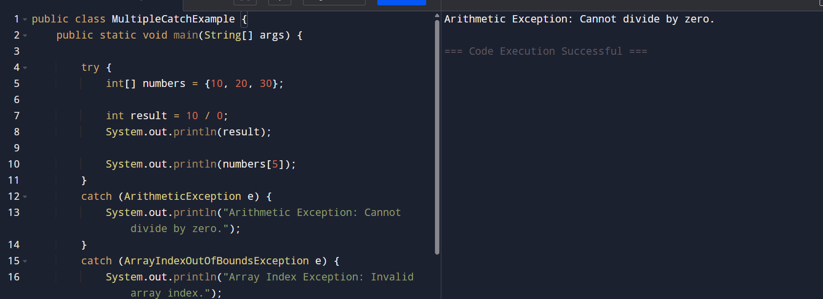
Q2. StringIndexOutOfBoundsException
public class StringIndexExample {
public static void main(String[] args) {

try {
String str = "Java";

System.out.println("String: " + str);
System.out.println("Character: " + str.charAt(10));
}
catch (StringIndexOutOfBoundsException e) {
System.out.println("String Index Out Of Bounds Exception");
System.out.println("Invalid index. String length is only " + strLength());
}
}

static int strLength() {
String str = "Java";
return str.length();
}
}
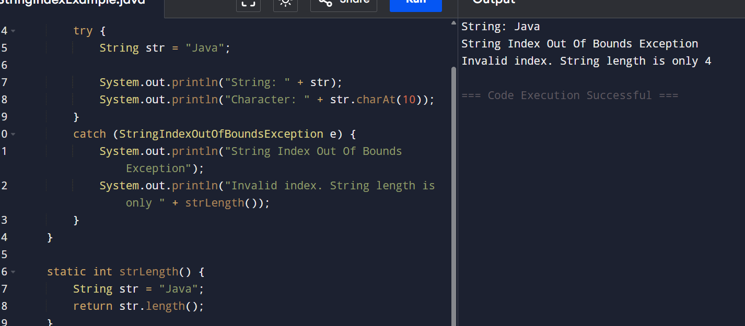

Q3. finally \
public class FinallyExample {
public static void main(String[] args) {

try {
int a = 10;
int b = 2;

int result = a / b;

System.out.println("Result: " + result);
}
catch (ArithmeticException e) {
System.out.println("Cannot divide by zero.");
}
finally {
System.out.println("Finally block is always executed.");
}
}
}
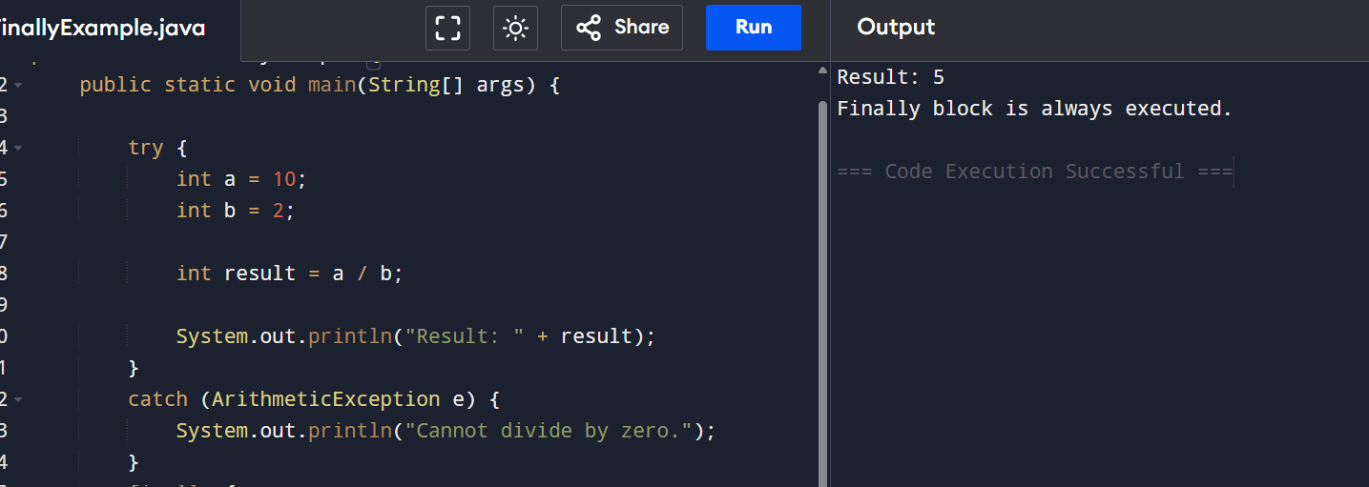
Q4. throw – Check Person Eligibility to Vote
public class VotingEligibility {

static void checkAge(int age) {

if (age < 18) {
throw new ArithmeticException("Person is not eligible to vote.");
}
else {
System.out.println("Person is eligible to vote.");
}
}

public static void main(String[] args) {

try {
checkAge(16);
}
catch (ArithmeticException e) {
System.out.println(e.getMessage());
}
}
}
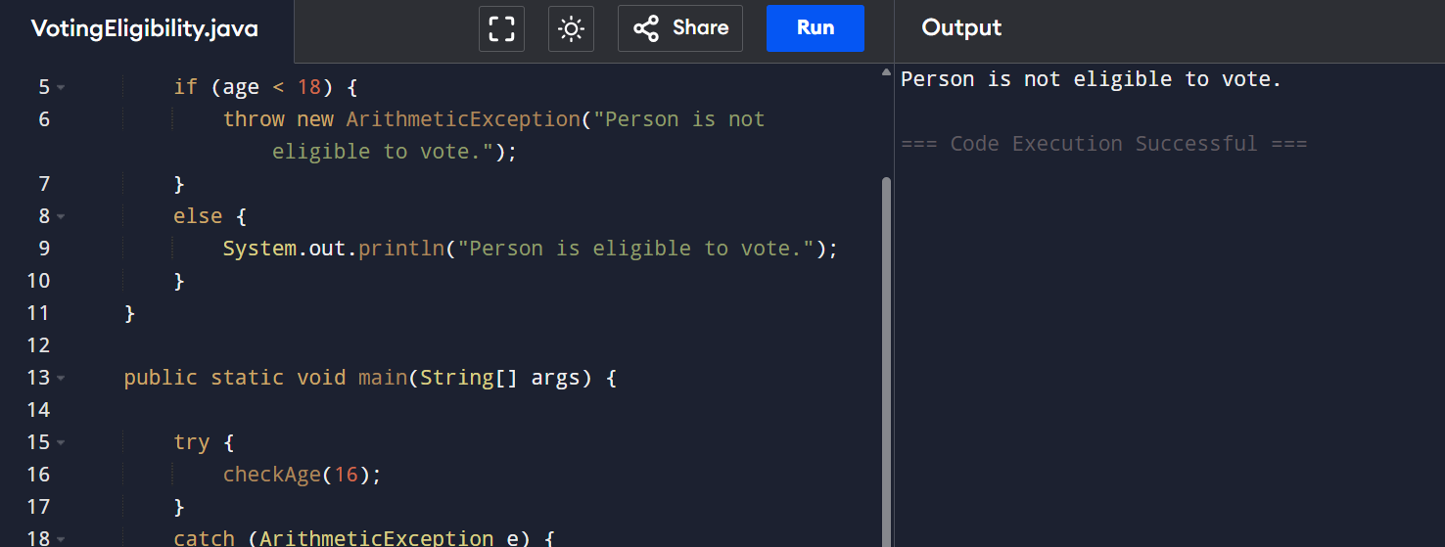
Q5. throws
public class ThrowsExample {

static void checkNumber(int number) throws Exception {

if (number < 0) {
throw new Exception("Negative number is not allowed.");
}

System.out.println("Number is valid.");
}

public static void main(String[] args) {

try {
checkNumber(-5);
}
catch (Exception e) {
System.out.println("Exception: " + e.getMessage());
}
}
}
